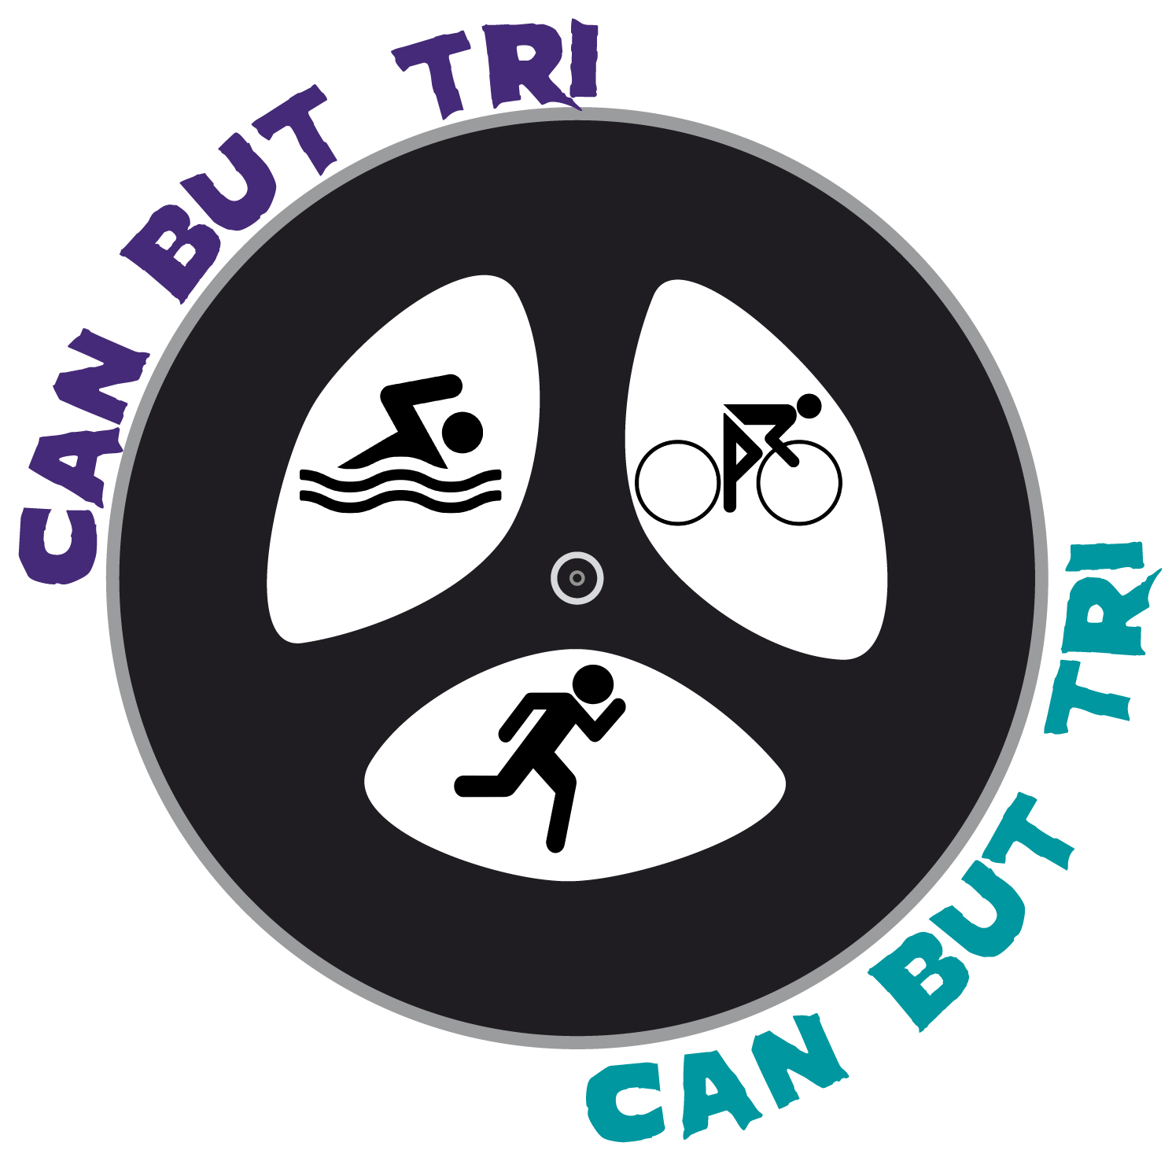
Enduro Duathlon
High Lodge – 24th October 2021
Race Results

Ladies

First Name | Surname | Bib | Laps | Time | Position
Jo | Fisk | 76 | 10 | 03:00 | 1
Heather | Guttery | 74 | 7 | 02:49 | 2
Julie | Eldridge | 65 | 7 | 03:03 | 3

Gentlemen

First Name | Surname | Bib | Laps | Time | Position
Ian | White | 100 | 12 | 03:02 | 1
Neal | Watson | 108 | 12 | 03:03 | 2
Elliott | Norris | 38 | 12 | 03:04 | 3
Mark | Fountain | 90 | 12 | 03:08 | 4
Karle | Howard | 50 | 12 | 03:10 | 5
James | Crawford | 57 | 12 | 03:10 | 6
James | Manly | 47 | 12 | 03:15 | 7
Jason | Blackwell | 39 | 11 | 02:53 | 8
Jay | Ferman | 99 | 11 | 03:07 | 9
Ethan | Fitzpatrick | 107 | 11 | 03:14 | 10
Mark | Moden | 94 | 10 | 02:49 | 11
Thomas | Fay | 66 | 10 | 02:52 | 12
Lewis | Tippett | 78 | 10 | 03:00 | 13
Benn | Eldridge | 23 | 10 | 03:08 | 14
Gary | Pryor | 102 | 9 | 02:57 | 15
Lee | Goddard | 70 | 8 | 02:11 | 16
Charlie | Wilson | 103 | 8 | 03:05 | 17
John | West | 24 | 7 | 03:02 | 18
Tim | Bowman | 112 | 4 | 01:00 | 19
Tristan | Haskins | 62 | dns

Congratulations to everyone who took part and especially those who made the podium!

